Industrial Visit: Vejalpur Startup Festival 2025
An industrial visit was organized to the Vejalpur Startup Festival 2025 on 23 March 2025 at JADE Banquet, Ahmedabad. The visit aimed to expose students to the startup ecosystem, innovation culture, and government initiatives supporting entrepreneurship.
The visit was attended by Jainam Sir along with students of 5th and 3rd semester. As Visitors, participants explored the startup exhibition, interacted with founders, and gained insights into emerging business models, funding opportunities, and incubation support. The event enhanced understanding of real-world industrial practices, innovation trends, and entrepreneurial networking, making it a valuable experiential learning opportunity.

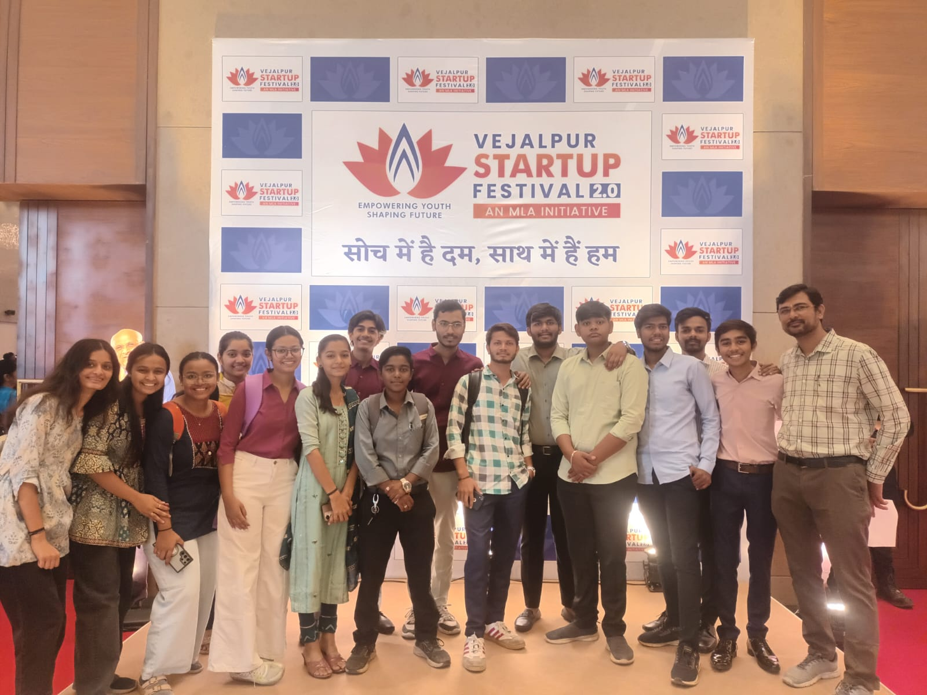 | 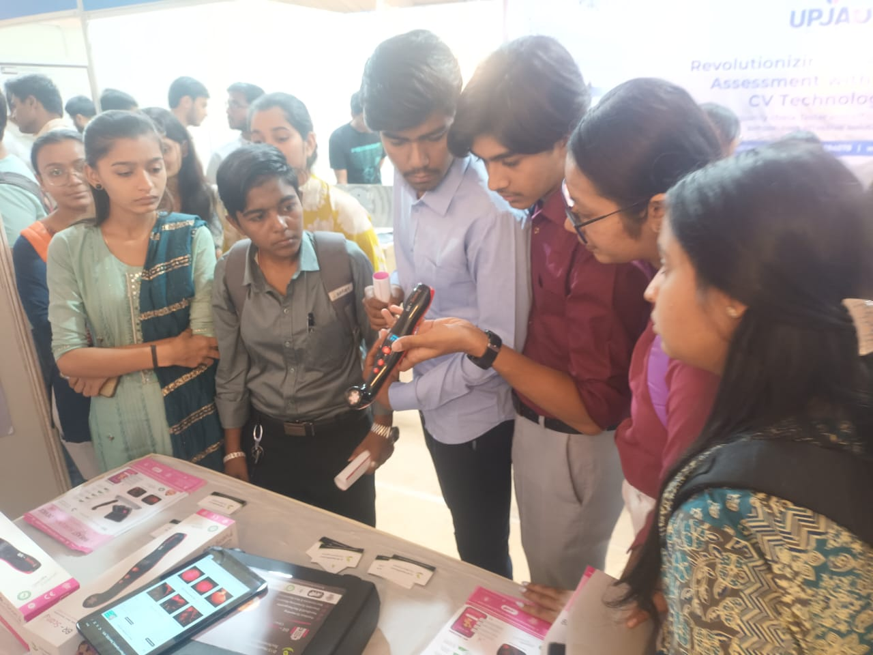
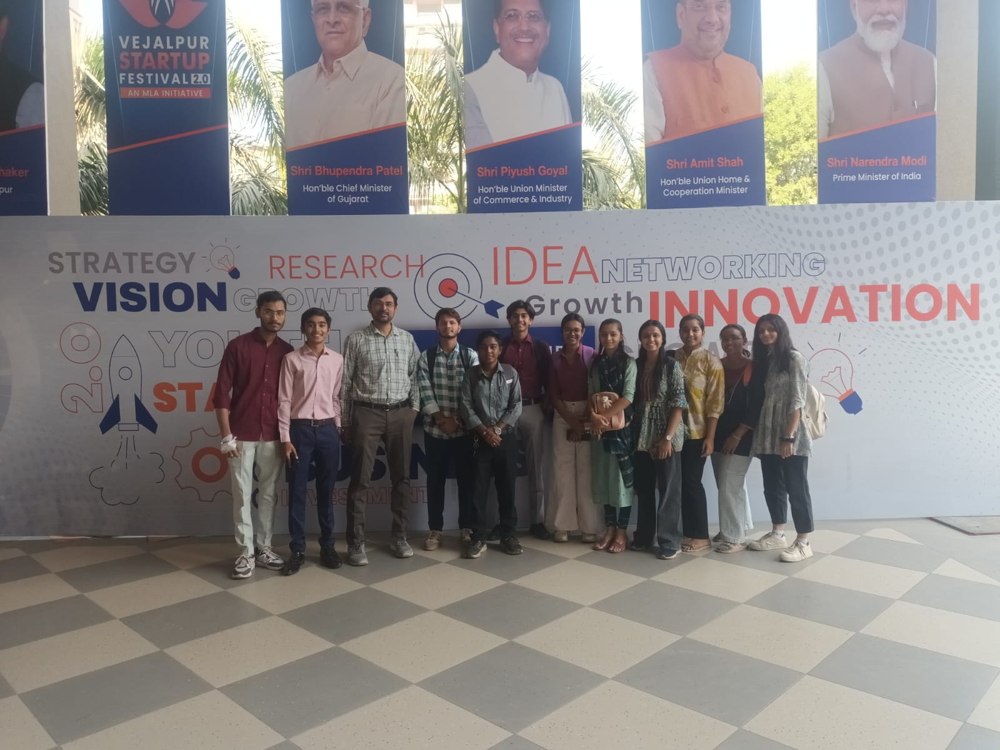 | 